System Requirement Specifications (SRS)

# 1 Table of Contents

**1 Table of Contents** **2**

**2 Problem Statement** **4**

**3 Overview** **4**

3.1 Background 4

3.2 Overall Description 5

**4 Investigation & Analysis Methodology** **5**

4.1 System Investigation 5

4.2 Analysis Methodology 5

4.2.1 Feasibility study and requirement elicitation 5

4.2.2 System analysis and requirement elicitation 6

4.2.2.1 Perform an analysis of the problem using object-oriented techniques 6

4.2.2.2 Scope and Limitations 6

4.2.3 Object-oriented design using UML 6

4.2.4 Prototyping 8

**5 Constraints** **8**

5.1 Manual mapping of camera frame to seat location 8

5.1 Real time detection 8

5.3 Project Schedule 9

**6 Operational Requirements** **9**

6.1 Help Desk Support 9

6.2 Application Services and Technical support 9

6.3 Administration Features 9

**7 Functional Requirements** **9**

7.1 Student Self-service 9

7.1.1 Student Account 9

7.1.2 View Seats 10

7.1.3 Seat reservation 10

7.2 Librarian Management 10

7.2.1 Admin Account 10

7.2.2 Seat Management 10

7.2.3 Alert 10

7.2.4 Report 10

7.3 Detection System 11

7.3.1 Human detection 11

7.3.2 Object detection 11

**8 Non-functional Requirements** **11**

8.1 Security 11

8.2 Reliability 11

8.3 Performance 11

**9 Input Requirements** **12**

9.1 Student account 12

**10 Process Requirements** **12**

10.1 Database seat update 12

10.2 Data integrity 12

10.3 Data validation 12

10.4 Performance 12

10.5 Data repository 12

**11 Output Requirements** **12**

11.1 Seat report summary 12

11.2 Reservation confirmation 13

**12 Hardware Requirements** **13**

12.1 Network 13

12.2 Computers 13

12.3 Mobile devices 13

12.4 WiFi cameras 13

**13 Software Requirements** **13**

13.1 Client Operating System 13

13.2 Mobile Operating System 13

13.2 Web application 13

13.3 Network system 14

13.4 Licenses 14

**14 Deployment Requirements** **14**

# 2 Problem Statement

The public libraries have a limited number of seats available and are unable to cope with the high volume of students during peak period such as examination period. The seats in the library are limited and valuable. Despite the limited seats some students will hog the seat and be away from the seat for an extended period of time. Thus, the seat will become unavailable for other students.

# 3 Overview

## 3.1 Background

In Singapore, public libraries have been developed to steer away book repositories and quiet sanctuaries to become a crucial common space in society, said S. Iswaran, Minister for Communications and Information, in 2020. Common spaces such as seats and booths in the library accommodates to the people from all walks of life, such as students studying, the elderly reading the newspaper or parents bringing their kids to encourage reading.

With an increasing percentage of the population now going to universities, it only meant that there will be a decreasing amount of common space available to students at the university. Especially in the libraries, study and reading spaces such as common seats and tables and individual booths are getting crowded, and it is becoming a norm that people are fighting to get the best seats as soon as the library opens .

Especially during examination period, a trip to the library is likely to elevate the students’ stress, as they face difficulties in searching for a vacant seat to do their revision for the examinations. Moreover, they will be wasting time looking for a vacant seat, instead of using the time for studying.

Without a proper seat management system in place, the libraries at Nanyang Technological University have been plagued with many issues such as seat hogging, as well as the uncertainties and frustrations faced when looking for a vacant seat.

A survey conducted with over 500 users who frequent the libraries at NTU revealed that over 85% of them often have difficulties locating vacant seats in the library, with around 80% stating that they often spend more than 5 minutes in the library to locate a vacant seat.

In addition, seat hogging is a prevalent issue in the library, where users leave their belongings at the seat and leave for a long period of time, thus depriving other users of vacant seats. The conducted survey also revealed that over 70% of them have witnessed seat hogging in the library, and the top reason for doing so is to have their meals and to attend classes.

To mitigate this issue a SmartLib system should be inplace to detect seat hogging and have a reservation system to the library seats.

## 3.2 Overall Description

SmartLib is an intelligent system aimed to improve the experience at the libraries across Nanyang Technological University. Its main purpose is to address the issue of locating empty seats/booths at the libraries as well as mitigating seat hogging. SmartLib is a system that enables library users, mainly students, to check the current capacity of the library seats. They will also be able to view the availability of individual seats in the library. In addition, users will be able to reserve a seat at the library for a short period of time before walking over to the library, to ensure they can secure a seat to avoid unnecessary disappointment.

The SmartLib will have a web platform for users to interact with the system as stated. The target users will be the librarians, allowing them to view and manage the seats in the library and the students, allowing them to find empty seats and reserve the seats.

# 4 Investigation & Analysis Methodology

## 4.1 System Investigation

Cameras will be placed around the library to detect if the seat is occupied. The SmartLib system processes the image taken by the camera to determine if the seat is empty, occupied or being hogged. After processing the information, it will be stored into the database. The SmartLib interface will read the information stored in the database and update the seat status accordingly. The user will be able to interact with the interface to reserve and view the seats in the library. Once the system detects a hogged seat, it will alert the librarian through the interface.

## 4.2 Analysis Methodology

### 4.2.1 Feasibility study and requirement elicitation

To ensure that the objective of the stakeholders such as the student and librarians are satisfied by the system, a development and implementation team composed of people knowledgeable about the current issues will be organized with which regular meetings will be held.

To ensure the system is feasible and can be developed within the current time frame, a series of interviews with the managers and the developers of the SmartLib system will be arranged. Interview and feedback from the personnel and staff working directly with the system is needed to define the current environment and future system requirements.

To determine which requirements are the most appropriate based upon the results of the interview. A Feasibility and Risk Assessment study will be done on all the requirements

### 4.2.2 System analysis and requirement elicitation

#### 4.2.2.1 Perform an analysis of the problem using object-oriented techniques

An external view of the enterprise model will be formed via Unified Modeling Language (UML). This System Requirement Specification documents will form part of the documentation for the project.

Some of the desired features of the system include:

➢ Detect seat status

➢ The ability to view seats and make reservation

➢ The ability to authenticate the user when making reservation

➢ Librarians able to modify the seat status

➢ System to alert the librarians if the seat is hogged

➢ System able to generate a report for the librarians

➢ System to update and store the seat status

#### 4.2.2.2 Scope and Limitations

Analysis methodology will involve business analysis requirement analysis, data analysis, process analysis (web) and application architecture:

➢Business analysis – State the business rules, business system interfaces, business function, business ownership, sponsorship and associated project budget requirement

➢Requirement analysis – System I/O description, user requirement definition, functional and security requirement

➢Data analysis – Involve data collection process, data validation, data storage, manipulation and retrieval

➢Process analysis – Data/process flow analysis, process decomposition and system interfaces

➢Application architecture – Analyze application information structure, usability, user interface design, interaction and application implementation.

### 4.2.3 Object-oriented design using UML

A detailed object-oriented design for the SmartLinSystem will be developed. UML will be used again for the graphical representation and documentation of the design. The system will concern itself with the web process. At its core, a student will be able to view the seats status and book in real time through the web browser, the seat status information is retrieved from the back-end system database, firebase. In addition the system will alert the librarians for each seat that is marked as hogged. The use case will show how the user performs tasks on the website, the dialog map will show the user experience and the ER diagram will show how the data is mapped.

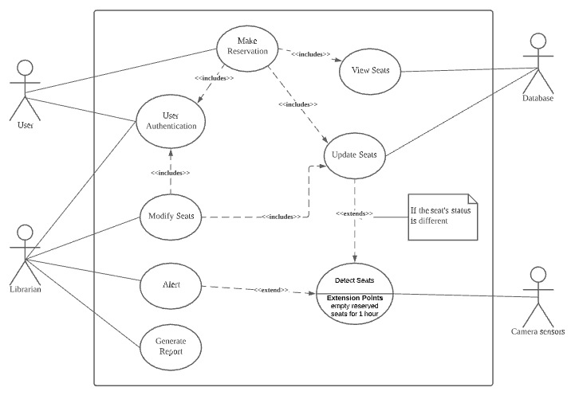

Use-case diagram

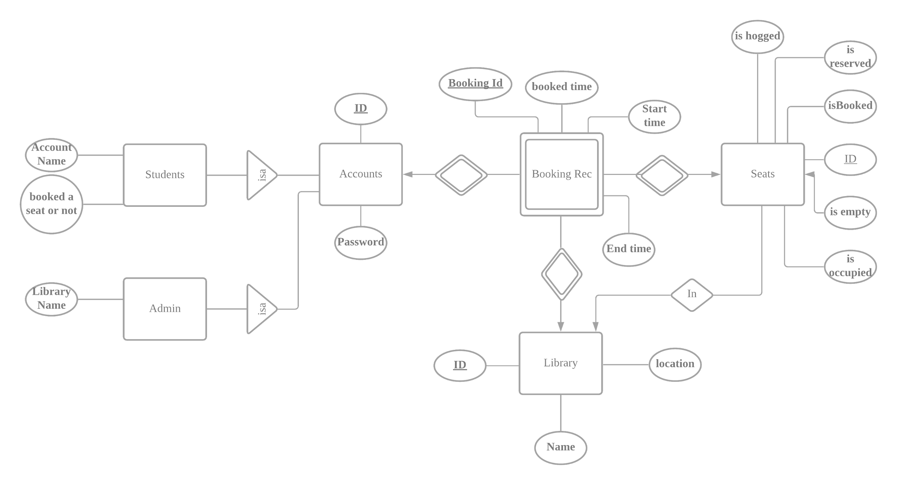

ER diagram

### 

Dialog Map

### 4.2.4 Prototyping

The Object Oriented Rapid Prototyping (OORP) method will be used to implement a limited and functional prototype for the registration system. The prototype will be a working example of part of the system for demonstration and proof of concept purposes only. It will include a web-based portal as an user interface, database to store the information of the seats and a middleware to process the video stream from a WiFi camera, The prototype will be presented to the implementation team.

# 5 Constraints

## 5.1 Manual mapping of camera frame to seat location

The frame from the camera has to be split into several mini-frame and mapped to corresponding seats. For the initial product, this will be done manually by the team.

## 5.1 Real time detection

The SmartLib system requires high computational power for deep learning models to detect the status of the seat in real time. There’s a tradeoff between speed and accuracy for different sizes of the deep learning model. So , the team has to find a balance to carry out accurate and real time seat status detection.

## 5.3 Project Schedule

There is a six-month timeframe to implement a production system of an online registration system from project commencement in time for Fall 2021 registration.

# 6 Operational Requirements

## 6.1 Help Desk Support

Smartlib provides support through various channels such as telephone and email during the business hours for problems such as, slow or sluggish system response time, incompatible browser features, application errors, system downtime inquiries, account lock-out assistance, etc.

## 6.2 Application Services and Technical support

The application developers from the SmartLib team will have access to the source code of the system to solve bugs or perform system updates when necessary. The network and DBA support is also required to maintain the system uptime during the library operational hours.

## 6.3 Administration Features

SmartLib has different levels of system access and functional authority for different users. The students can only access to his booking functionalities whereas the authorized system administrator(s) can access to the seats management system.

# 7 Functional Requirements

The SmartLib is a “self-service style” system that addresses students' need to find and book a seat in the library. It also provides additional functions for the librarian to better manage the library. All system (browser) interfaces are based on ISO accepted industry standards for the WWW.

## 7.1 Student Self-service

### 7.1.1 Student Account

Sign up - email, matrix number,student name, password, forget password

7.1.1.1 The system must be able to authenticate the user based on their account details

7.1.1.2 The account details consist of the student matric number

### 7.1.2 View Seats

7.1.2.1 The students must be able to the view all the seat status in the library

7.1.2.2 The seats in the library will be displayed according to the levels

7.1.2.3 The seat status must be either occupied, reserved, empty or hogged.

7.1.2.4 The system will display the seat in red for occupied, orange for reserved, green for empty and black for hogged.

### 7.1.3 Seat reservation

7.1.3.1 The user must be able to book an unoccupied seat

7.1.3.2 The system must be able to update the seat status on the database

7.1.3.3 The system will send a booking confirmation email to the user

7.1.3.4 The booking confirmation email will contain the student name, seat number and reserved time.

7.1.3.4 The seat will be booked for 15 mins

7.1.3.5 The system will cancel the booking if the seat is not occupied within the 15 mins

## 7.2 Librarian Management

### 7.2.1 Admin Account

7.2.1.1 The admin account must be provided

7.2.1.2 The admin account must consist of a password and a username

7.2.1.3 The system must be able to authenticate the librarian based on the admin account details

### 7.2.2 Seat Management

7.2.2.1 The librarian must be able to manage user bookings and modify the individual seat occupancy status accordingly.

7.2.2.2 The librarian must be allowed to overwrite the occupancy status of each seat in the library (Eg. As part of Covid-19 rules of safe distancing)

### 7.2.3 Alert

7.2.3.1 The system must alert the librarian if a seat is hogged

7.2.3.2 A seat is considered hog if the seat is occupied with an object for more than an hour

7.2.3.3 The alert will be displayed on the system interface

7.2.3.4 The alert must contain the seat number.

### 7.2.4 Report

7.2.4.1 The system must be able to generate a seat occupancy report of the

Library daily.

7.2.4.2 The report must contain the all the seat status every hour.

## 7.3 Detection System

### 7.3.1 Human detection

7.3.1.1 The system must be able to detect human on a seat with an accuracy of 90%

7.3.1.2 The system must be able to update the seat status to occupied if a human is detected

### 7.3.2 Object detection

7.3.2.1 The system must be able to detect objects on a seat with an accuracy of 90%

7.3.2.2 The system must be able to update the seat status to hogged if an object is detected on a seat for more than an hour.

# 8 Non-functional Requirements

## 8.1 Security

8.1.1 The system must protect against unauthorized access by requesting login information and user authentication.

8.1.2 The system must restrict the library management function from non-admin users.

## 8.2 Reliability

8.2.1 The system must be available 99% of the time.

8.2.2 The system must be able to handle errors made by the user.

8.2.2.1 Errors such as wrong login information and invalid inputs.

8.2.2.2 The system must be able to prompt the user if any errors occur.

8.2.3 The system must be able to backup and store the database every day.

8.2.4 The system must be able to reboot in less than 5 minutes.

8.3.5 First time users must be able to book a seat within 5 minutes.

## 8.3 Performance

8.3.1 The system must be able to load within 30 seconds.

8.3.2 The seat display must be updated periodically after any changes to the seat status.

# 9 Input Requirements

## 9.1 Student account

The unique identifier for each student account is their matric number. The student must know this. This identifying keys maps all his/her reservation information in the system. Admitted and current students must have their accounts enabled. Such accounts may be disabled during his/her stay as a matriculated student and/or after graduation or separation from the university.

# 10 Process Requirements

## 10.1 Database seat update

The system must be able to update and receive the seat status from the database system.

## 10.2 Data integrity

Seat status information of the system must be the same on all interfaces.

## 10.3 Data validation

Data error from the users’ end and from the back-end-database-processing end must be gracefully handled. There will be data validation and error-handling as part of the smart library system.

## 10.4 Performance

The system must be running and working during the library operation hours.

## 10.5 Data repository

The smartlib system will maintain the database as the main repository of data.

# 11 Output Requirements

## 11.1 Seat report summary

Librarians must be able to extract summarized and rolled-up data into meaningful information regarding the library seat occupancy. All records will be archived but accessible on demand.

## 11.2 Reservation confirmation

After each reservation, the user must have a view of the summary of the reservation for the particular seat. The database will be able to display all past reservations.

# 12 Hardware Requirements

## 12.1 Network

University network infrastructure (wired and wireless)

## 12.2 Computers

Mac, Unix and windows computer

## 12.3 Mobile devices

Android and Iphone mobile device

## 12.4 WiFi cameras

Camera with WiFI capability and a resolution of 1280 x 720

# 13 Software Requirements

## 13.1 Client Operating System

UNIX(any flavour), MAC, WIndows

## 13.2 Mobile Operating System

Android , IOS

## 13.2 Web application

React compatible browser:

* Google chrome
* Microsoft Edge
* Mozilla Firefox
* Opera

## 13.3 Network system

Network software and protocols in order for the systems to communicate:

* TCP/IP
* HTTP
* HTTPS

## 13.4 Licenses

Valid licenses are required to run software from third-party vendors:

* To use application development tools.
* To use web server, application server and database software in development, test and production mode

# 14 Deployment Requirements

